**Lecture 7: Research Example**

**An example of using Python to study the effect of killing on spatial structure in bacterial populations**

<https://www.nature.com/articles/ncomms14371>



Type 6 secretion systems (T6SS) are protein machine used by a wide range of bacterial species to transport proteins from one cell to another. Typically, they are used to transport a toxin into a 2nd cell, killing it by targeting conserved bacterial proteins or cell wall components. They play an important role in interbacterial warfare. A schematic of how they work is shown below:

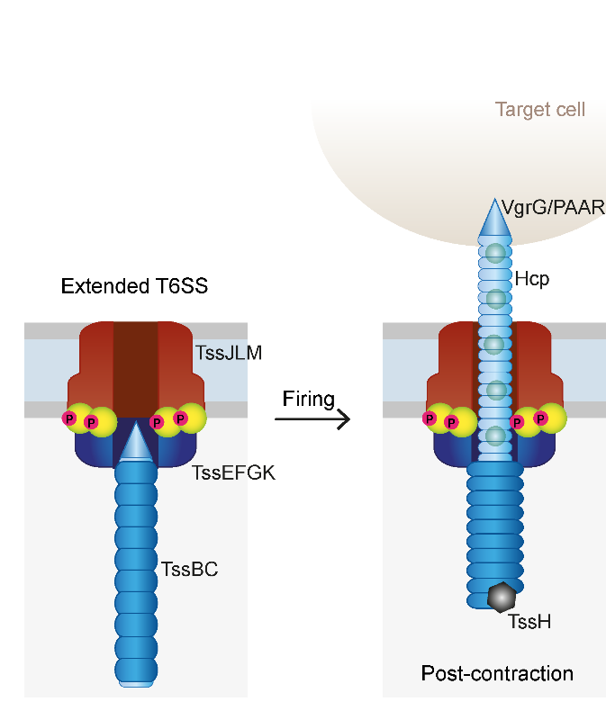

Interestingly, it was found that bacterial cells could not kill their offspring or any closely related cells. This is because cells also express an antidote that counter acts the toxin’s effect.

In the paper above, the authors explored how these systems could create spatial structure in populations, allowing cooperative interactions through the local release of enzymes that are necessary for processing food (chitin) to bring it into the cell. The authors use the following system:

In *Vibrio cholerae,* T6-proficient strains utilize the T6SS to intoxicate T6-deficient eukaryotic predators and diverse proteobacteria, as well as other more closely related *V. cholerae* isolates that lack identical effector immunity pairs[26](https://www.nature.com/articles/ncomms14371#ref26),[27](https://www.nature.com/articles/ncomms14371#ref27),[28](https://www.nature.com/articles/ncomms14371#ref28),[29](https://www.nature.com/articles/ncomms14371#ref29),[30](https://www.nature.com/articles/ncomms14371#ref30),[31](https://www.nature.com/articles/ncomms14371#ref31),[32](https://www.nature.com/articles/ncomms14371#ref32). T6-mediated segregation occurs during co-culture of T6-proficient *V. cholerae* with T6-deficient *E. coli*. Segregation was also predicted to occur between two mutually antagonistic T6-proficient strains[33](https://www.nature.com/articles/ncomms14371#ref33), and recently demonstrated at the single cell level in co-cultures of *V. cholerae* and *Aeromonas hydrophila*[20](https://www.nature.com/articles/ncomms14371#ref20).

In other words, each bacterial species, *V. cholerae* and *A. hydrophila*, can kill each other, but not themselves. When you mix these species together, bacterial warfare ensues, where each species tries to kill each other. The authors show that in these situations, phase separation occurs, where each of the two species represents a single phase. A key figure from this paper is reproduced below, showing each species in red or blue:



The authors used a variety of modeling and laboratory experiments to demonstrate this, including a straightforward Python script you should be able to reconstruct based upon what you know already. From the Methods:

We randomly seeded a 500 × 500 lattice with an equal number of red and blue cells. Every time step, 5% of the cells were randomly chosen to activate their T6SS systems, killing any adjacent (eight cells surrounding the focal cell) cells of the opposite colour. Similarly, 5% of the cells in the landscape were randomly chosen to attempt to reproduce, filling up to one adjacent unoccupied patch with a cell of its colour. Rates of killing and reproduction were chosen to provide sufficient temporal resolution of population dynamics while still being computationally efficient. Reproduction was aborted if all neighbouring patches were occupied. Within each time step, model updates were propagated sequentially across rows, starting with the first position in the upper left corner. This model was coded in Python and is available upon request.

Your job is to implement this code. I have created a starting python file for you to use as a template.